**Field Work**

**On**

**Meesho**

**(Online Shopping App)**

**Submitted to**

**KCES’s Institute of Management and Research, Jalgaon**



**Submitted by**

**Name: Mr. Krushna Suresh Sonawane**

**Email id:** [**kskd143437@gmail.com**](mailto:kskd143437@gmail.com)

**Name: Mr. Yugandhar Battu Gujar**

**Email id:** [**gujaryugandhar5@gmail.com**](mailto:gujaryugandhar5@gmail.com)

**Under the Guidance of**

**Name**: **Miss. Aarati Hinge**

**In Partial Fulfillment of**

**Master of Computer Application ( Integrated)**

**KCES’s Institute of Management and Research, Jalgaon**

**ACKNOWLEDGEMENT**

We have great pleasure in submitting this Field Work on **“Meesho (The Online Shopping App Feedback)”** to **KCES’s Institute of Management and Research, Jalgaon.**

It is humble brief that any Field Work can be carried out with success by a two person. Many other personalities helpings to accomplished this project and it is our duty to express our appreciation to them.

We are indebted to **Mrs. Aarati Hinge** for helping us as guide and allow up do the Field Work at their site.

We wish to thank the teaching staff, our friends and persons who help us directly or indirectly for completion of Field Work.

**DECLARATION**

We hereby declare that the project work entitled **“Meesho”** has carried out result on the basis of investigations and analysis by us under the guidance of **Miss. Aarati Hinge**

We further declare that this work has not been submitted in partly or fully to any other University or Institute for the award of any other degree. Material obtained from other source has been daily acknowledged in the Field Work.

**INDEX**

| **Sr. No.** | **TOPIC** | **Page No.** |
| --- | --- | --- |
| **1** | **Abstract** | **5** |
| **2** | **Introduction** | **6** |
| **3** | **Project Field Work Topic / Literature Review** | **7** |
| **4** | **Objectives** | **9** |
| **5** | **Methodology** | **10** |
| **6** | **Result and Discussion** | **12** |
| **7** | **Recommendations and Future Work** | **14** |
| **8** | **Suggestion** | **15** |
| **9** | **Conclusion** | **16** |
| **10** | **References** | **17** |
| **11** | **Questionnaire** | **18** |

**1.Abstract**

**Meesho** is a mobile-based social commerce platform that enables individuals, especially small business owners and entrepreneurs, to start their online businesses with zero investment. Launched in India, Meesho provides a user-friendly interface where users can browse, select, and resell products—ranging from fashion and home décor to electronics and beauty items—primarily through social media channels like WhatsApp, Facebook, and Instagram. The app simplifies the supply chain by connecting suppliers directly with resellers, offering features such as order management, secure payments, and logistics support. With a focus on empowering individuals, particularly women and first-time internet users, Meesho aims to democratize e-commerce in emerging markets through technology and innovation.

**2. Introduction**

**Meesho** was founded in **December 2015** by **Vidit Aatrey** and **Sanjeev Barnwal**, both graduates of IIT Delhi, with the vision to empower individuals, especially homemakers and small entrepreneurs, to start their own online businesses with minimal investment. Initially launched as Fashnear Technologies, **the company rebranded to Meesho in 2016**, meaning "**Meri Shop**" (My Shop), to better reflect its mission. Meesho pioneered social commerce in India by enabling resellers to sell products through social media platforms like WhatsApp and Facebook without holding inventory. Over the years, the platform saw rapid growth, raising significant funding rounds, including investment from Meta (Facebook) in 2019, becoming the **first Indian** startup to do so. **By 2020**, Meesho had **millions** of users and processed millions of orders monthly. The company continued to expand its offerings and user base, becoming one of India’s leading social commerce platforms. In recent years, Meesho has introduced **logistics services and AI-**powered customer support, further strengthening its ecosystem. As of 2025, Meesho is preparing for its **initial public offering (IPO)**, marking its transition from a startup to a major player in the e-commerce space, with a focus on empowering small sellers across India.

**Meesho** is an online marketplace that enables individuals, especially small business owners and resellers, to sell a wide range of products such as clothing, accessories, home goods, and more—primarily through platforms like WhatsApp, Facebook, and Instagram. Founded in 2015, Meesho aims to **empower entrepreneurs** by providing them with a platform that requires **zero investment**, making it easy for anyone to start their own online business.

**3.Project Field Work Topic / Literature Review**

**Meesho**, founded in **2015 by Vidit Aatrey and Sanjeev Barnwal**, is an Indian e-commerce platform that enables individuals, particularly women in Tier-2 and Tier-3 cities, to start their own online businesses with zero investment. By leveraging social media platforms like WhatsApp and Facebook, Meesho facilitates a reselling model where users can market and sell products without holding inventory.

The rise of social commerce platforms has transformed the e-commerce landscape, particularly in emerging markets like India. **Meesho** stands out as a pioneering platform enabling resellers to start online businesses without upfront investment by leveraging social networks. This literature review explores academic and industry research focused on Meesho, social commerce, and its impact on entrepreneurship and digital inclusion.

**1. Social Commerce and Digital Entrepreneurship**

Social commerce blends social media and e-commerce, allowing users to buy and sell products within social networks. Research by Wang et al. (2020) highlights social commerce as a powerful tool for micro-entrepreneurs to access wider markets with minimal capital. Platforms like Meesho empower individuals, especially women and rural populations, by providing digital tools and networks to start small businesses (Kumar & Jha, 2021).

**2. Meesho’s Business Model**

Studies (Sharma & Singh, 2022) analyze Meesho’s zero-inventory model where resellers market products via social channels without maintaining stock. This model reduces entry barriers and operational risks. Meesho acts as a middle layer connecting suppliers and resellers, handling logistics, payments, and customer support, which enhances the reseller’s experience.

**3. Impact on Women Empowerment and Financial Inclusion**

Meesho’s focus on women entrepreneurs is widely discussed in social entrepreneurship literature. According to Roy & Banerjee (2023), Meesho has contributed significantly to women’s financial independence by providing them flexible earning opportunities aligned with their schedules. This resonates with broader studies (Desai & Patel, 2020) on digital platforms promoting gender inclusivity in emerging economies.

**4. Challenges and Limitations**

Despite its success, literature points to challenges such as product quality control, digital literacy gaps among resellers, and intense competition (Chatterjee & Rao, 2022). User trust and customer retention remain crucial for platform sustainability.

**5. Technological and Market Trends**

Recent articles emphasize the role of AI and data analytics in enhancing personalized recommendations and efficient supply chain management in Meesho (Verma, 2024). The increasing smartphone penetration and internet accessibility in rural India are expected to expand Meesho’s reach.

**4.Objectives**

1. **Empower Small Entrepreneurs:**  
   To enable individuals, especially homemakers, small business owners, and people in tier 2 and tier 3 cities, to start their own online reselling business with minimal investment.
2. **Promote Social Commerce:**  
   To leverage social media platforms like WhatsApp, Facebook, and Instagram as sales channels for resellers, making online selling accessible to everyone.
3. **Simplify E-commerce:**  
   To provide a user-friendly platform where resellers can easily browse products, place orders, and manage their business without the need for inventory or technical knowledge.
4. **Connect Suppliers and Resellers:**  
   To act as a bridge between manufacturers/suppliers and resellers, facilitating seamless product sourcing and delivery.
5. **Generate Employment and Income:**  
   To create opportunities for income generation by supporting entrepreneurship and self-employment, especially in underserved areas.
6. **Provide Affordable Products:**  
   To offer a wide range of quality products at competitive prices, benefiting both sellers and customers.
7. **Scale Digital Inclusion:**  
   To encourage digital adoption and economic participation by empowering non-tech-savvy users through simple, social commerce-driven models.

**5. Methodology**

This survey method was used to collect data from responders who are user of Meesho.

In this study the researcher used questionnaire method as tool. The questionnaire was prepared on the basis of collected information and reviews about Online Shopping App. All the questions are structured on the basis of fulfilling the objective of the study.

Random sampling method was used for the study.The total sample size was 76 including both male and female users.The collected data was tubulated and analyzed

### **1**. **Research Design**

* **Type of Study:**  
  Descriptive and exploratory study to understand the operations, impact, and challenges of Meesho’s social commerce platform.
* **Approach:**  
  Mixed-method approach combining both qualitative and quantitative data collection.

### 2. **Data Collection Methods**

* **Primary Data:**
  + **Surveys:** Structured questionnaires targeted at Meesho resellers (mostly women entrepreneurs) to gather data on demographics, income changes, challenges, and satisfaction.
  + **Interviews:** Semi-structured interviews with a sample of resellers, suppliers, and Meesho officials to gain in-depth insights into operational aspects and user experiences.
  + **Observation:** Monitoring user interaction with the app and reseller activities to understand usage patterns.
* **Secondary Data:**
  + Review of existing reports, articles, company publications, and academic papers related to Meesho, social commerce, and digital entrepreneurship.
  + Analysis of app store reviews and social media feedback to gather user sentiments.

### 3. **Sampling**

* **Target Population:**  
  Meesho resellers, primarily from Tier 2 and Tier 3 cities, along with suppliers connected to the platform.
* **Sampling Technique:**
  + **Purposive Sampling:** Selecting respondents who are active Meesho users or suppliers.
  + **Sample Size:** 50-100 resellers for surveys and 10-15 for in-depth interviews (adjust based on resources).

### 4. **Data Analysis**

* **Quantitative Data:**  
  Statistical analysis using software like Excel, SPSS, or Google Sheets to analyze survey responses, identify trends, and measure impact.
* **Qualitative Data:**  
  Thematic analysis of interview transcripts and observation notes to identify common themes, challenges, and success stories.

### 5. **Ethical Considerations**

* Ensure confidentiality and anonymity of respondents.
* Obtain informed consent before data collection.
* Use data solely for research purposes.

### 6. **Limitations**

* Potential bias in self-reported data from resellers.
* Limited access to company internal data.
* Geographic constraints based on sample selection.

**6. Results and Discussion**

### **Results :**

Meesho, as a leading social commerce platform in India, has demonstrated significant growth in user base, seller engagement, and transaction volumes over recent years. Key findings include:

* **User Growth:** Meesho's user base has expanded rapidly, reaching millions of active resellers across urban and rural areas. This growth is driven by the platform's easy onboarding process and strong support for first-time entrepreneurs, especially women.
* **Seller Engagement:** The platform boasts a diverse catalog of sellers and products, ranging from fashion to electronics and home goods. Many sellers leverage Meesho to tap into untapped markets by using social networks for sales.
* **Revenue and Transactions:** Meesho has witnessed a steady increase in monthly transaction volumes, with a corresponding rise in gross merchandise value (GMV). The integration of secure payment gateways and logistic partnerships has enhanced transaction efficiency.
* **Impact on Empowerment:** Data shows a notable increase in income levels for resellers, with a majority reporting improved financial independence and flexibility, especially among women entrepreneurs.

### **Discussion:**

The results underscore Meesho's role as a transformative force in India's digital commerce ecosystem. By enabling social selling, Meesho has bridged the gap between suppliers and consumers in less penetrated markets, driving financial inclusion and entrepreneurship.

* **Social Commerce Advantage:** Unlike traditional e-commerce, Meesho leverages social networks to facilitate personalized selling, which boosts trust and increases conversion rates. This model effectively harnesses community ties and word-of-mouth marketing.
* **Women Empowerment:** Meesho’s focus on empowering women entrepreneurs aligns with broader socio-economic goals. By providing low-barrier entry and training, the platform supports women who might otherwise face challenges in formal employment.
* **Challenges and Opportunities:** Despite its success, Meesho faces challenges such as maintaining product quality, managing logistics across diverse geographies, and combating counterfeit goods. Addressing these issues can further strengthen customer trust and platform sustainability.
* **Future Prospects:** The platform’s growth potential remains strong with increasing smartphone penetration and internet access in rural India. Additionally, innovations like AI-driven product recommendations and localized marketing can enhance user engagement.

**7. Recommendations and Future Work**

**Recommendations:**

Based on the current analysis and findings**.**

• **Enhance Quality Control Mechanisms:**  
To maintain customer trust, Meesho should implement stricter quality checks and seller verification processes. Introducing a rating system for products and sellers can incentivize better service and product standards.

• **Strengthen Logistics and Delivery Network:**  
Expanding partnerships with reliable courier services and exploring localized warehousing can reduce delivery times and costs, especially in rural and semi-urban areas.

• **Focus on User Education and Support:**  
Increasing training programs and resources for resellers, especially women, can improve sales skills and digital literacy. Offering multilingual support will also enhance accessibility.

• **Leverage Data Analytics and AI:**  
Using AI-driven insights for personalized recommendations and demand forecasting can improve customer experience and inventory management.

• **Combat Counterfeit and Fraudulent Products:**  
Developing robust anti-fraud algorithms and frequent audits can help minimize counterfeit goods on the platform, thereby protecting customers and legitimate sellers.

**Future Work:**

• **Exploring Emerging Technologies:**  
Investigate the integration of technologies like augmented reality (AR) for virtual try-ons and blockchain for transparent supply chain management.

• **Market Expansion Strategies:**  
Study the feasibility and challenges of expanding Meesho’s business model into international emerging markets with similar socio-economic dynamics.

• **Impact Assessment on Social and Economic Levels:**  
Conduct long-term studies to quantify Meesho’s impact on women empowerment, rural entrepreneurship, and local economies.

• **Sustainability Initiatives:**  
Research eco-friendly packaging solutions and sustainable sourcing to align with growing consumer preferences for green commerce.

• **Improved Customer Feedback Loops:**  
Develop more effective feedback mechanisms using AI to promptly address customer grievances and improve service quality.

1. **Suggetions**

• **Improve Seller Verification:**  
Implement a more rigorous onboarding process to ensure authenticity and reliability of sellers, reducing the risk of counterfeit products.

• **Enhance Customer Support:**  
Provide 24/7 multilingual customer service with faster resolution times to improve user satisfaction and trust.

• **Invest in Technology:**  
Use AI and machine learning to personalize the shopping experience, optimize logistics, and detect fraudulent activities proactively.

• **Focus on Training and Development:**  
Expand reseller training programs to improve sales techniques, digital literacy, and customer handling skills, especially targeting women entrepreneurs in rural areas.

• **Expand Payment Options:**  
Integrate diverse payment methods, including UPI, wallets, and EMI options, to cater to different customer preferences.

**9. Conclusion**

Meesho has emerged as a pioneering platform in India’s social commerce landscape, effectively bridging the gap between suppliers, resellers, and consumers through innovative technology and community-driven selling. Its unique model empowers millions, especially women entrepreneurs, by providing them with accessible tools to start and grow their businesses with minimal investment.

The platform’s rapid growth, coupled with its impact on financial inclusion and rural entrepreneurship, highlights its potential to transform traditional commerce in emerging markets. However, challenges such as quality control, logistics, and counterfeit goods need continuous attention to sustain trust and scalability.

By leveraging advanced technologies, enhancing user experience, and fostering community engagement, Meesho is well-positioned to maintain its competitive edge and drive inclusive economic growth. With strategic improvements and a focus on sustainability, Meesho can continue to empower individuals and reshape the future of social commerce in India and beyond.

**10. References**

* Meesho. (2024). *About Us*. Retrieved from <https://meesho.com/> about
* Economic Times. (2023). *How Meesho is Empowering Women Entrepreneurs in India*. Retrieved from <https://economictimes.indiatimes.com>
* TechCrunch. (2022). *Meesho Raises $300 Million to Expand Social Commerce*. Retrieved from <https://techcrunch.com>
* Statista. (2023). *Meesho: Monthly Active Users and Growth Statistics*. Retrieved from <https://statista.com>
* Indian Journal of Commerce. (2023). *The Rise of Social Commerce Platforms in India: A Case Study of Meesho*.
* Meesho (short for “Meri Shop”) is an Indian social commerce / e-commerce platform. [Wikipedia+2Snapshot+2](https://en.wikipedia.org/wiki/Meesho?utm_source=chatgpt.com)

**11. Questionnaire**

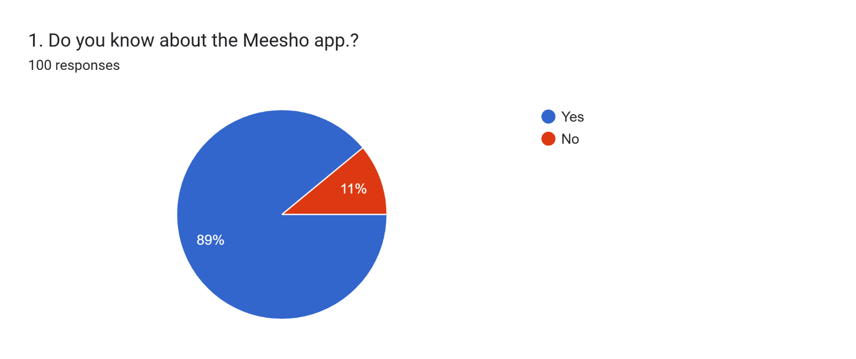

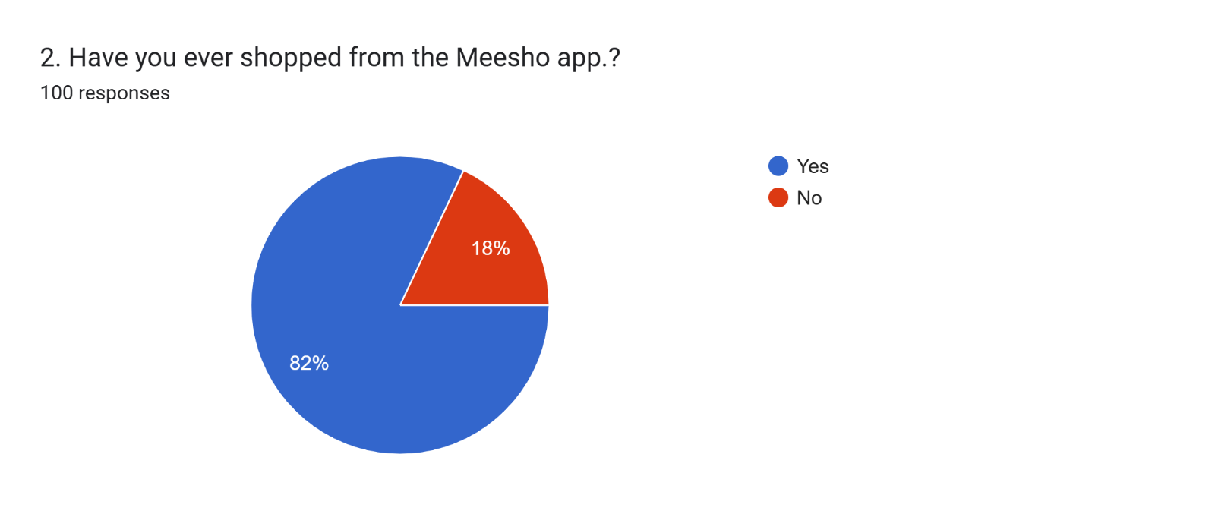

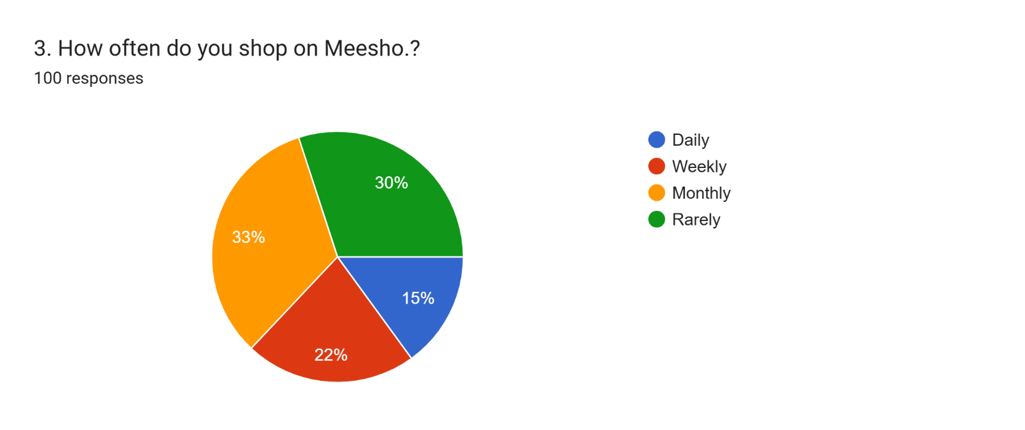

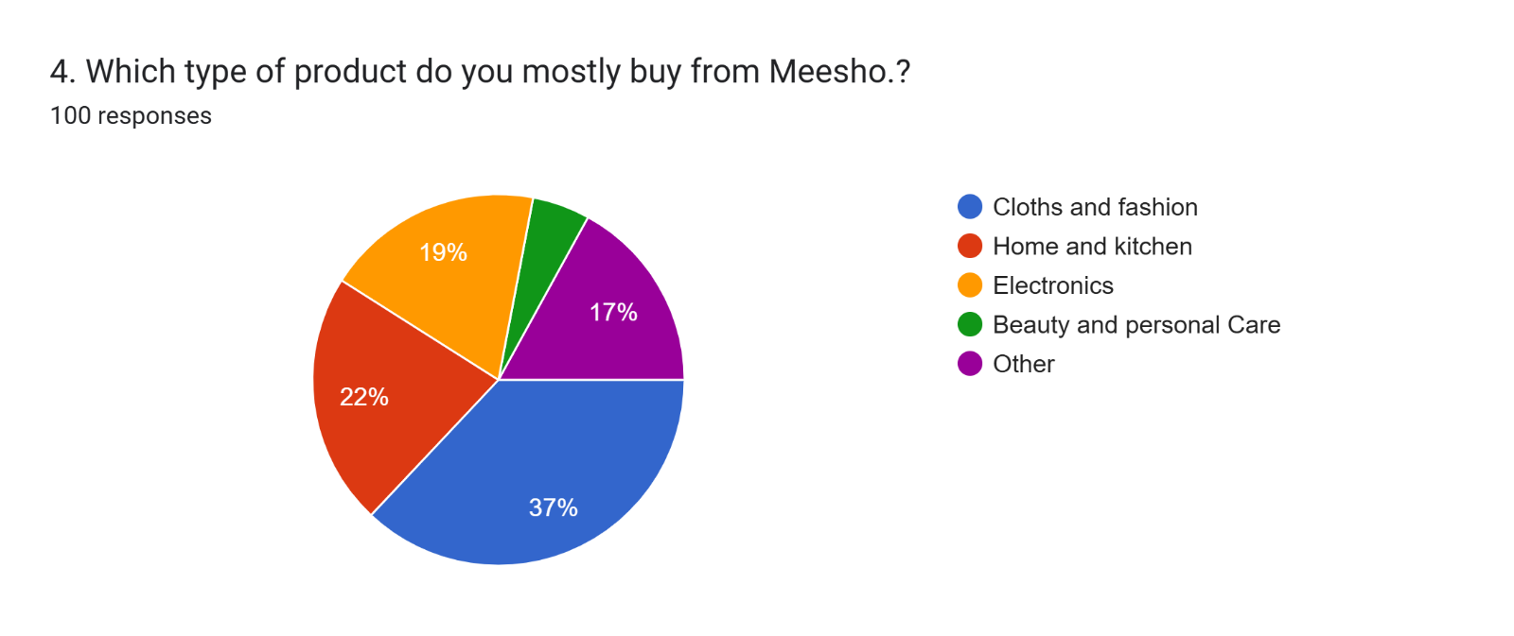

**Delivery experience:**

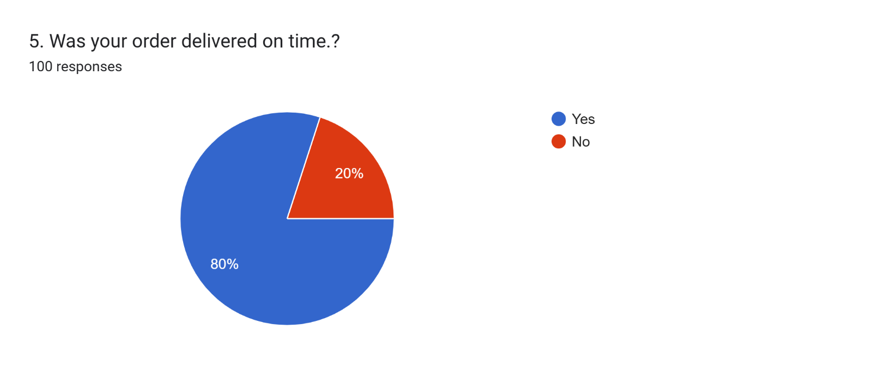

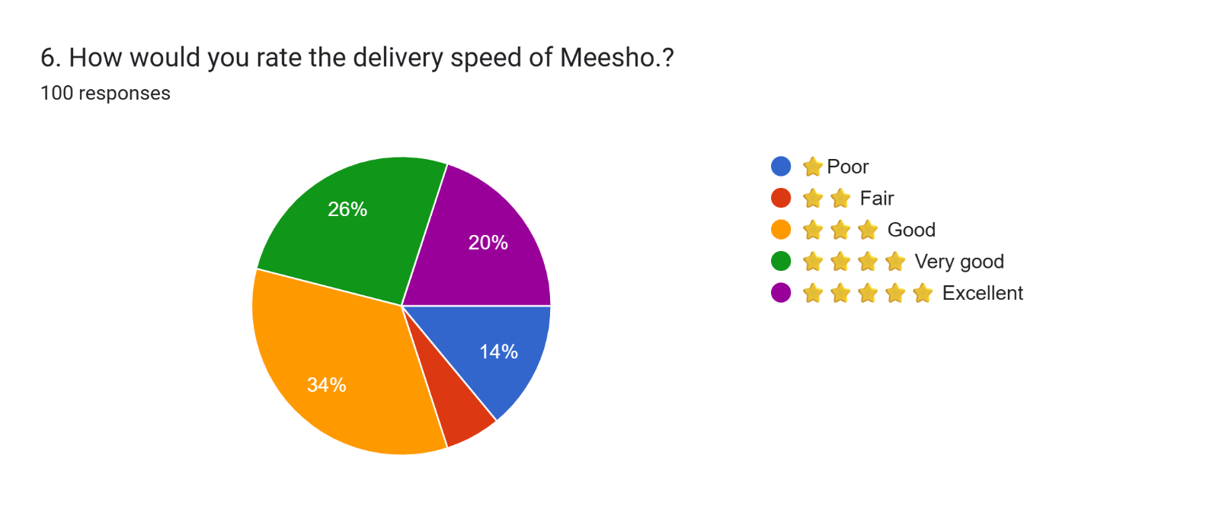

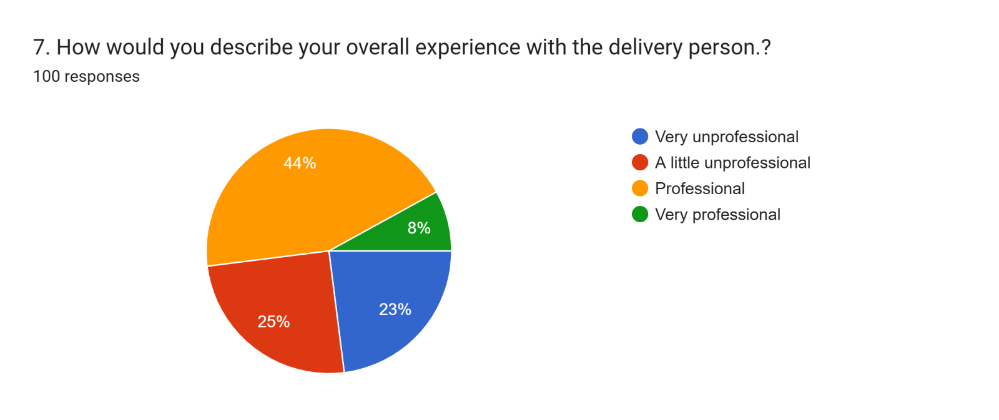 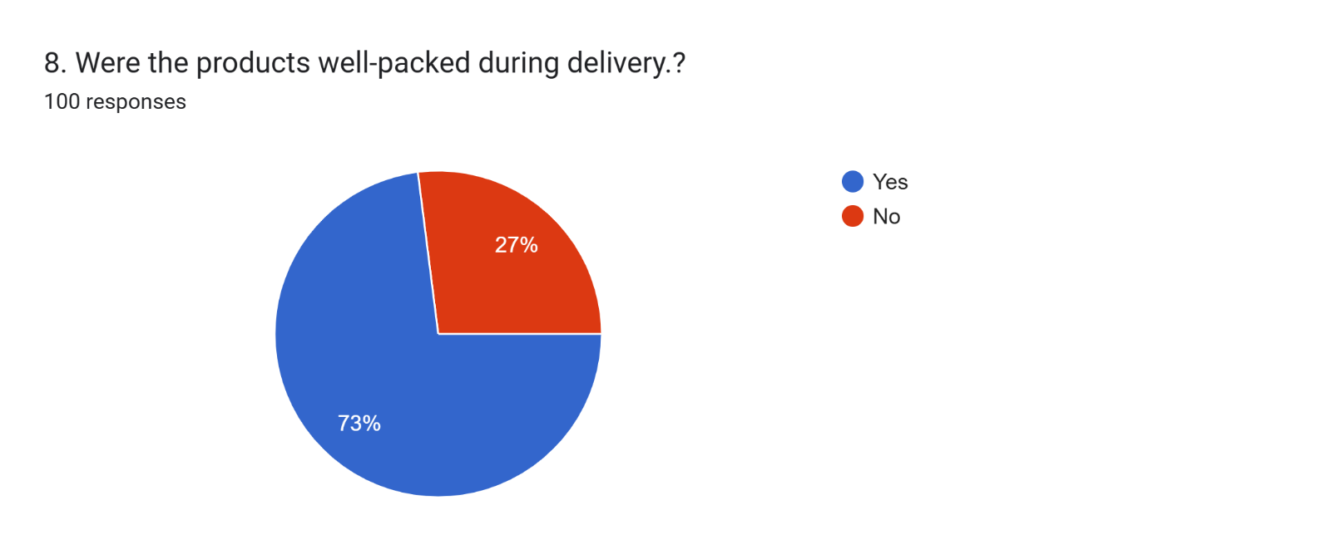 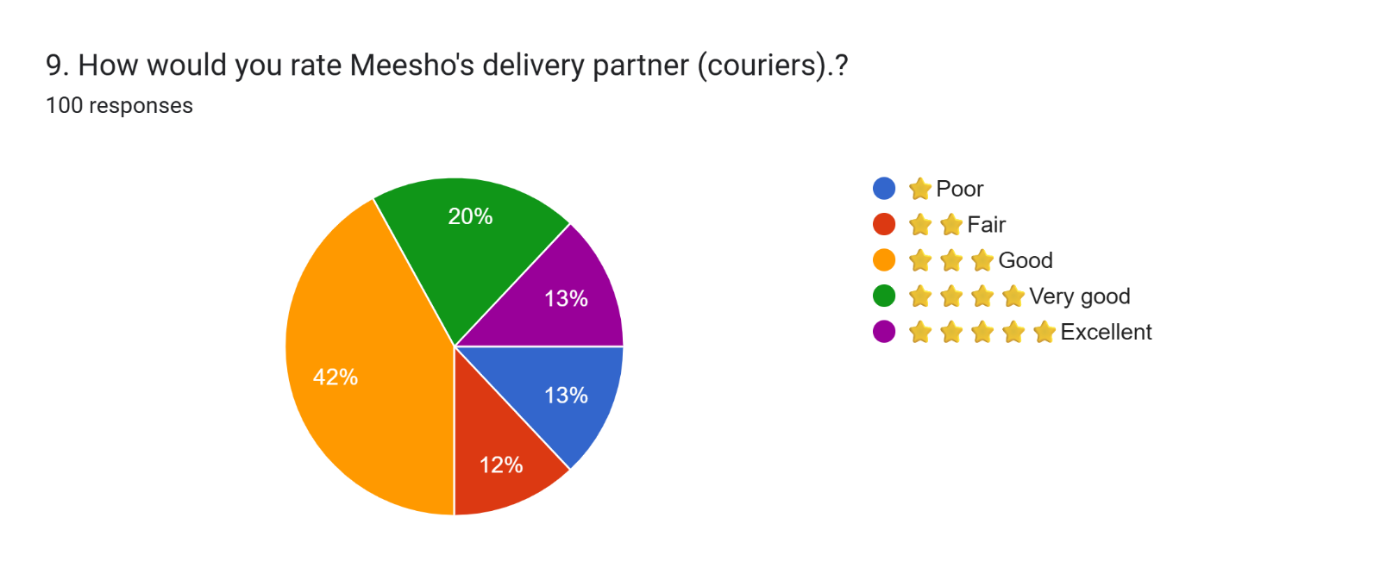 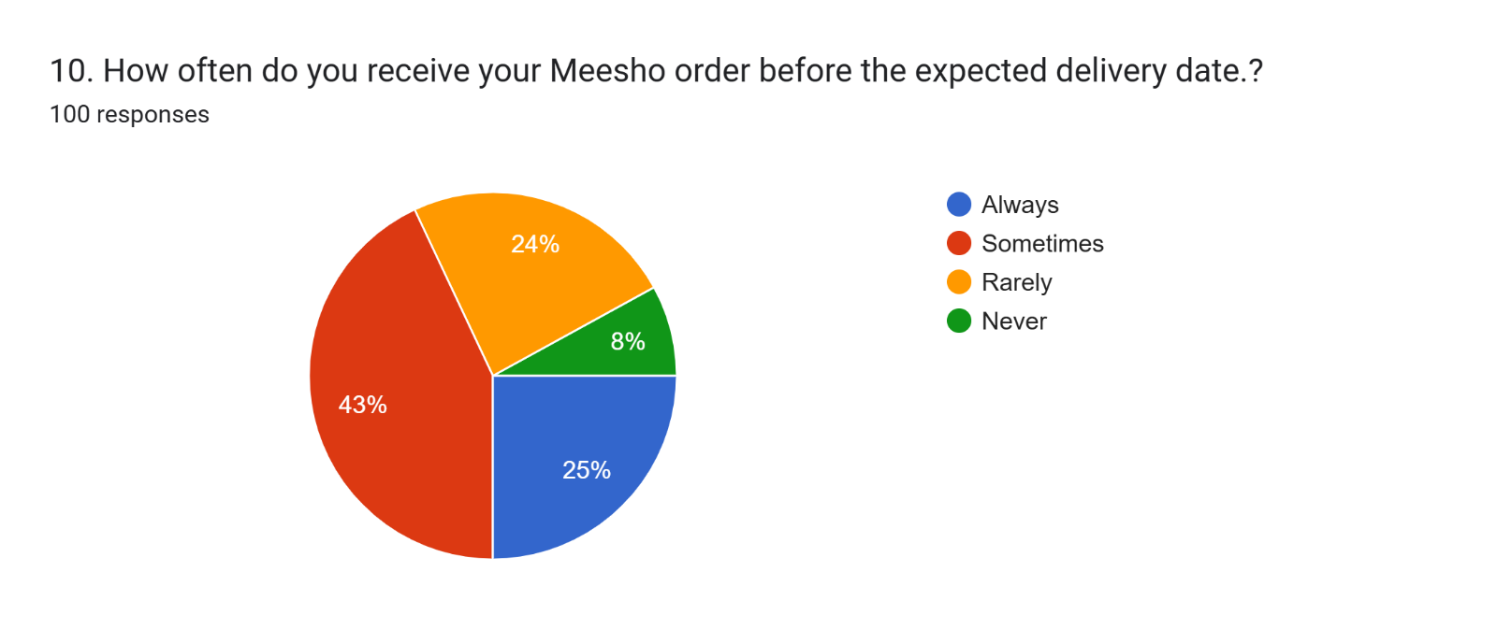

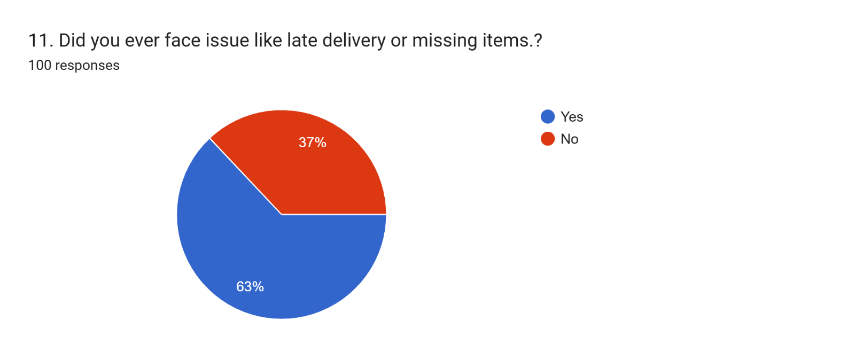 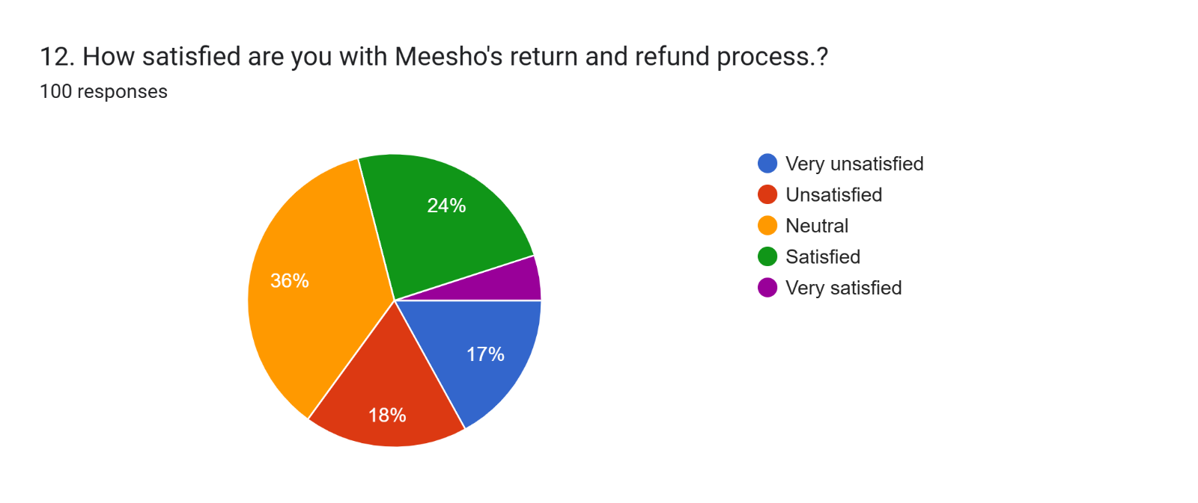 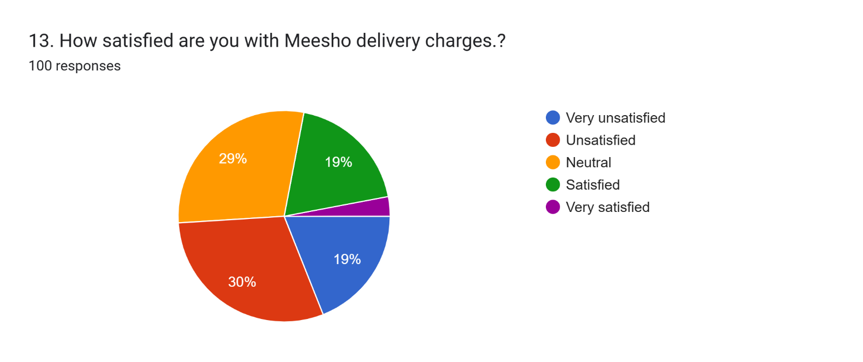

**App Experience:**

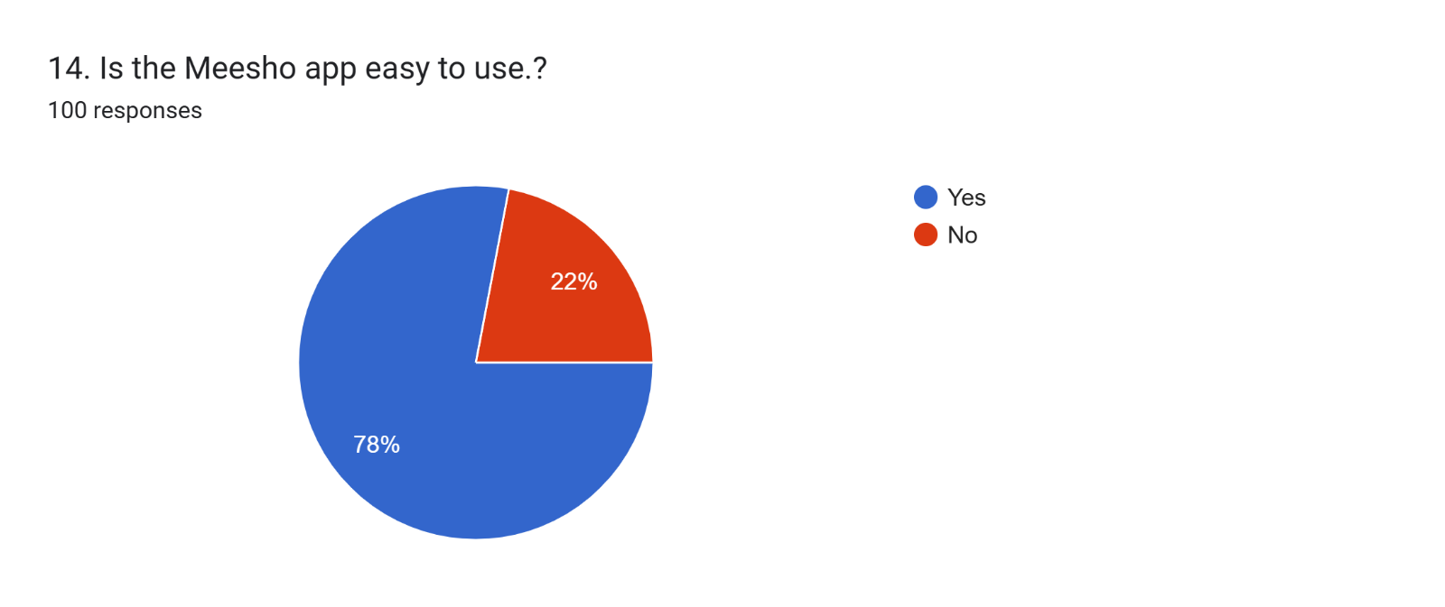 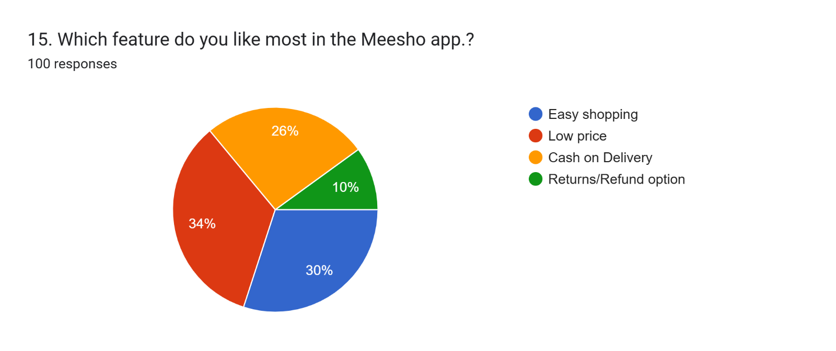 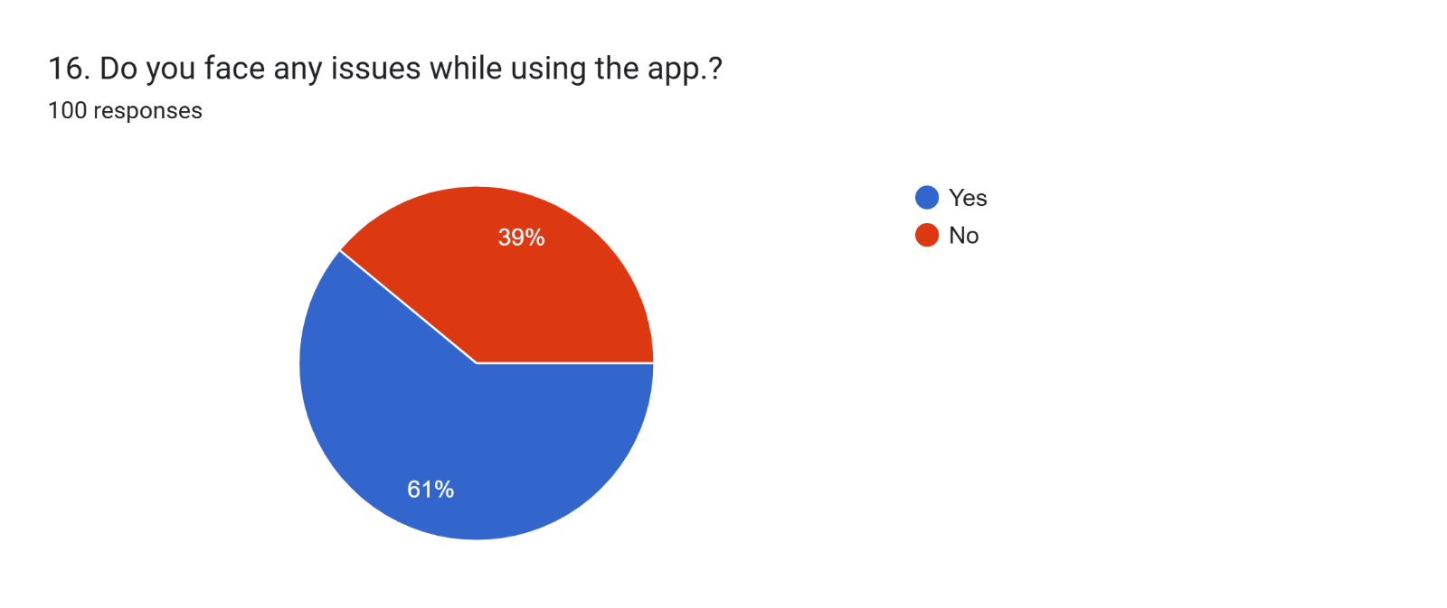 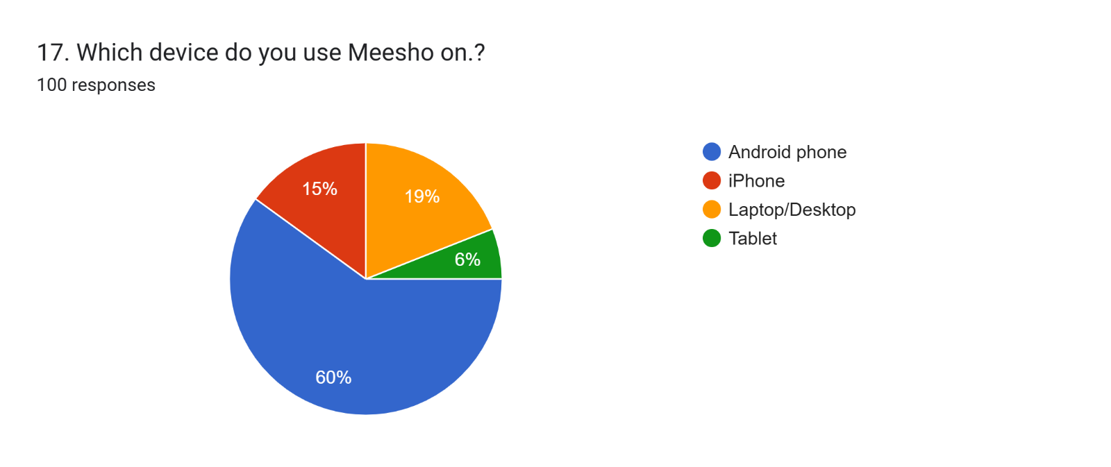

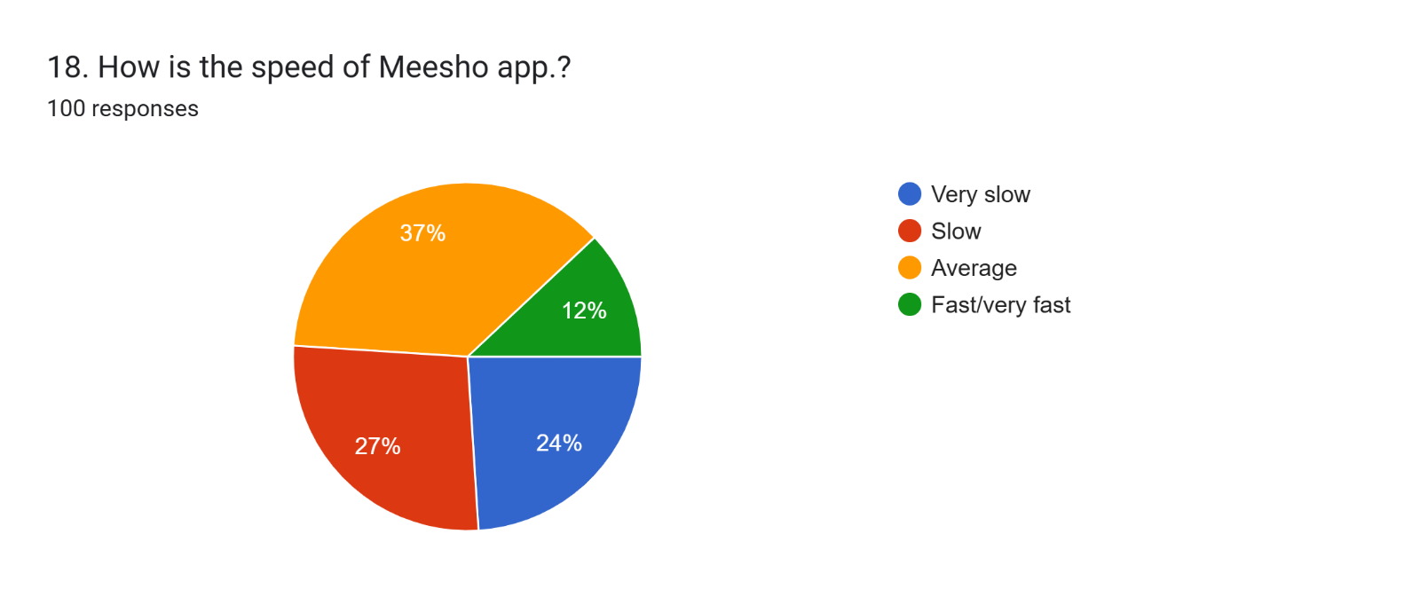 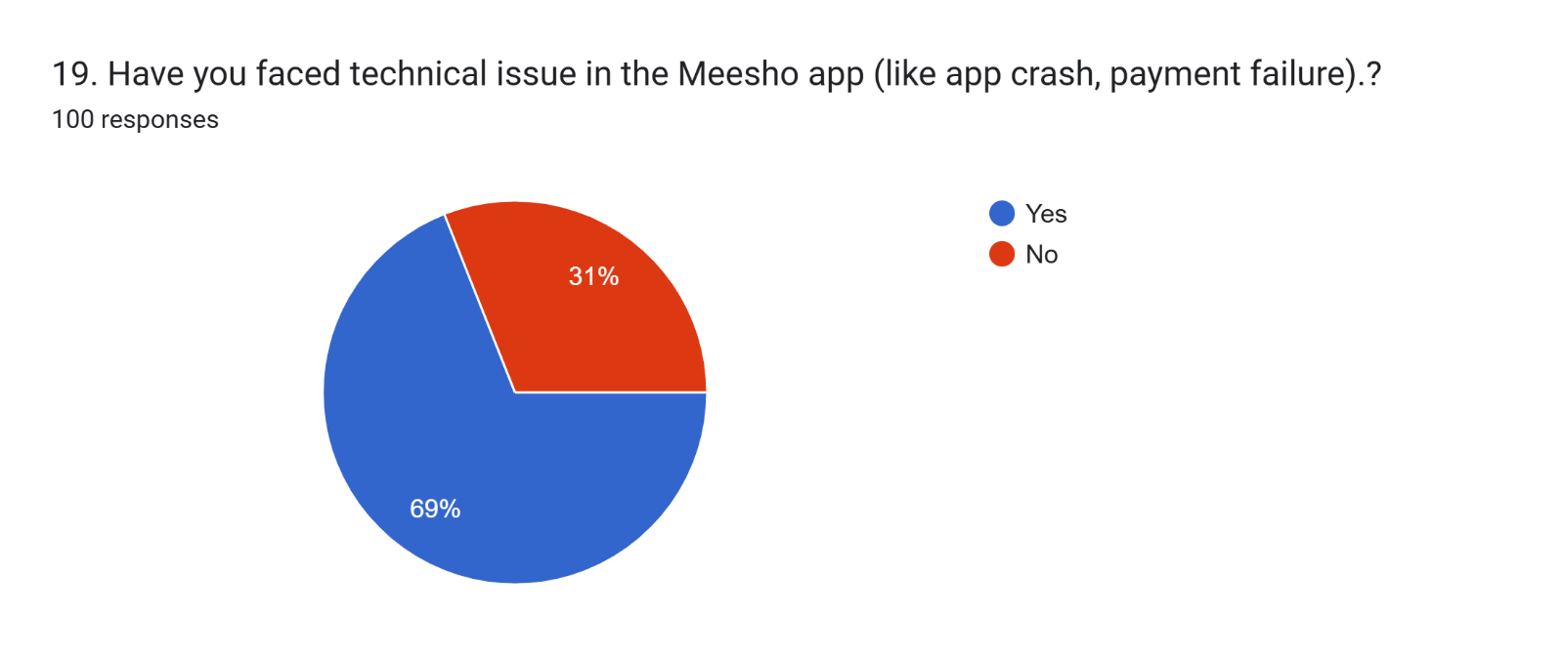 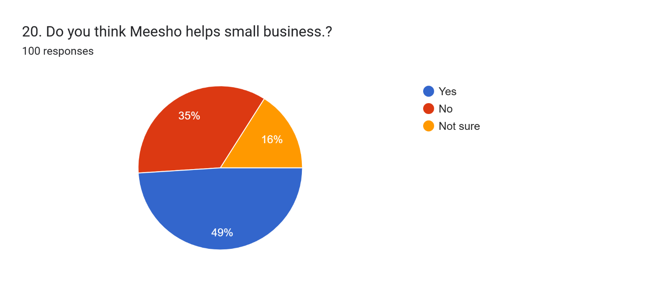 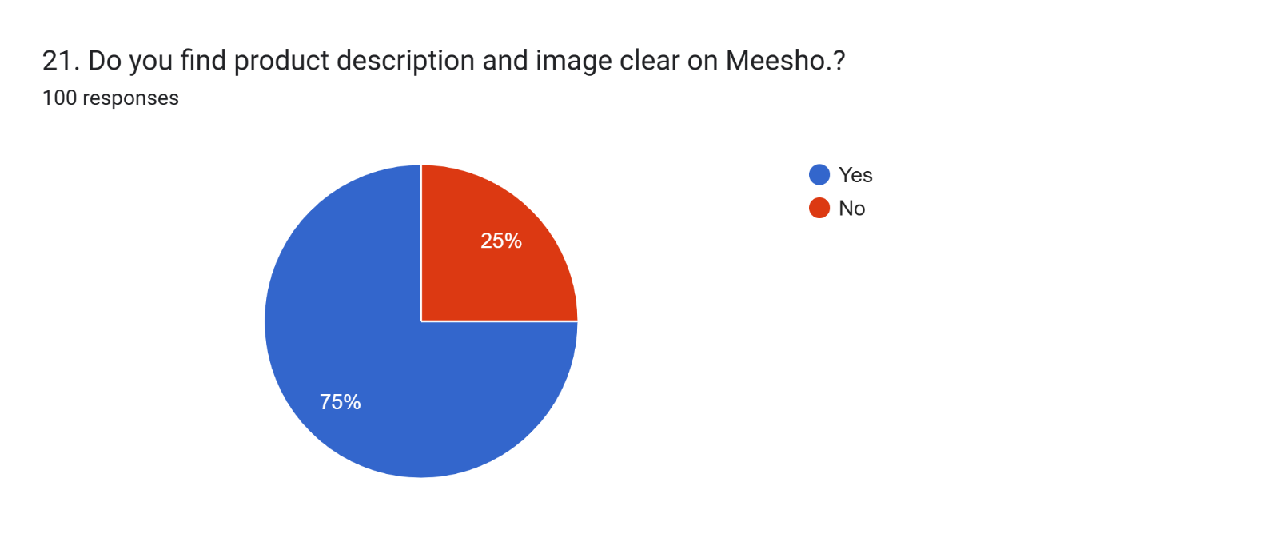 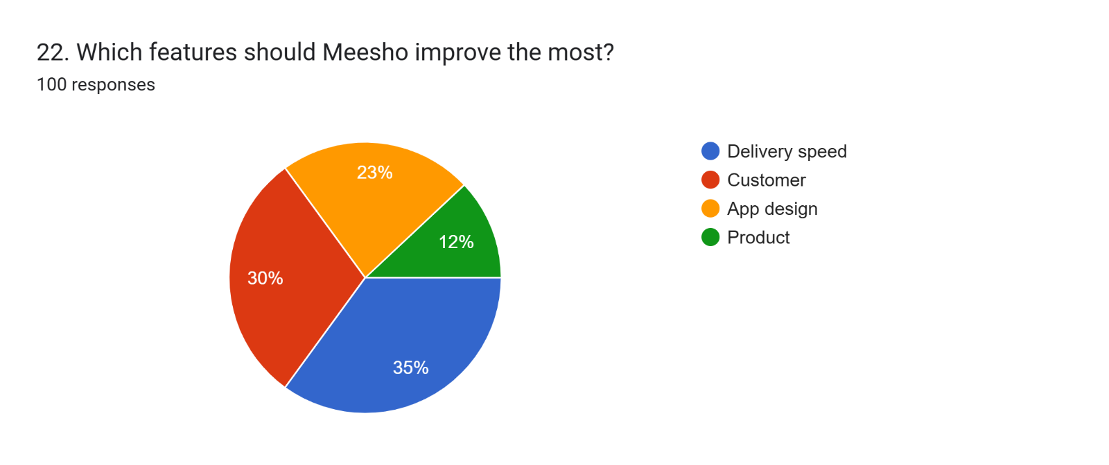 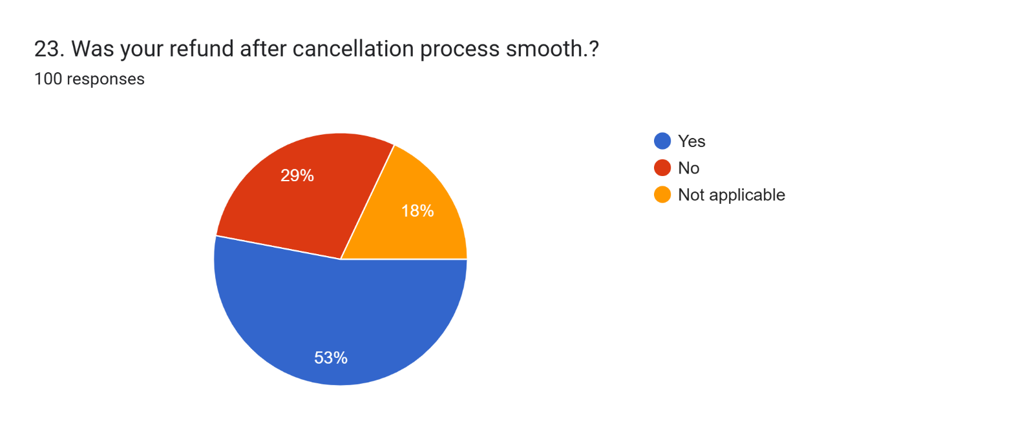

**Feedback:** 